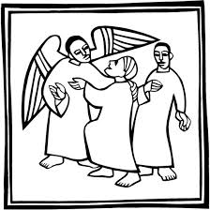

ST NINIAN’S UNITING CHURCH
PEBBLES NOVEMBER 9TH 2025
BASED ON LUKE 20:27-40

I Have a riddle for you! Mary’s father has 4 children; three are named Nana, Nene, and Nini. What is the name of his fourth child? The answer of course is Mary!
How many months have 28 days? All of them! some months do have 30 days or even 31 days, but they all have at least 28 days.
What is full of holes but can still hold water? A sponge!
Riddles have been around since the time of Jesus. Maybe longer than that. One day, Jesus was approached by a group of Sadducees – religious leader who didn’t believe that Jesus resurrected by God. They asked Jesus to answer a riddle: “The law of Moses says that if a man dies, leaving a wife but no children, his brother should marry the widow and have a child who will carry on the brother’s name. Well, suppose there were 7 brothers. The oldest one married and then died without children. So the Second brother married the widow, but he also died. Then the third brother married her. this continued until all 7 brothers had married the same woman. Finally, the woman also died. So tell us, whose wife will she be after the resurrection since all seven were married to her!”
My goodness, that is a bit of a riddle isn’t it! This is how Jesus answered the riddle.
Jesus said, “Marriage is for people here on earth. But in the age to come, those who are raised from the dead will not marry or be married. Not only that, but they will never die again. They will live forever as the children of God.” Luke 20:36
After Jesus answered their riddle so wisely, no one dared to ask him any more questions.
Now, you and I know that Jesus promised us that if we love him and trust him, we will live forever in heaven with him. Isn’t it sad that some people don’t believe there is a resurrection and God’s promise of eternal life in heaven? Oh, that reminds me, I have another riddle!
Why were the people in today’s story called Sadducees?
Since they didn’t believe in the resurrection or the happiness of heaven, they were “Sad, you see!” get it!! Sad-u-see

PRAYER: Dear Jesus, we are very happy today because you have promised us that we will live forever in heaven with you. Thank you that heaven is going to be the most amazingly fun and wonderful place to live. Heaven is going to be great and very beautiful. In Jesus’ name amen.

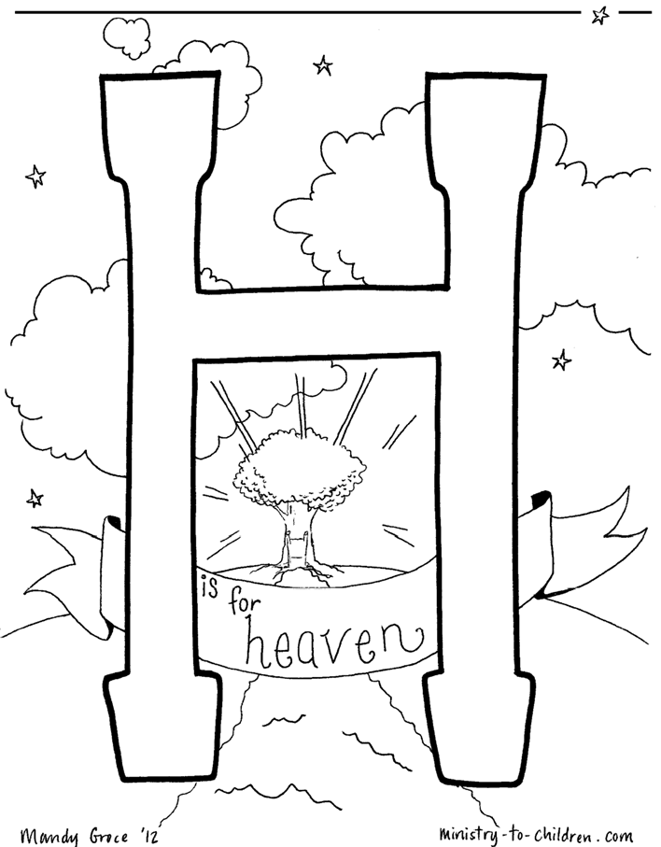

JESUS SADDUCEES MYSTERY MATH
